500 Hour Service
Shire 90
Boat Name: |  | Owner:
Location:
Engine Hours: |  | Date:

Description | Done | Comment
Check operation of all controls |  | Lubricate key switch
Check and adjust all alternator belts
Change engine oil filter (See Materials Used)
Change engine oil (See Materials Used)
Change gearbox oil (See Materials Used)
Change primary fuel filter (See Materials Used) |  | Fit the fuel filter drain screw and seal from the old filter to the new filter
Change secondary fuel filter (See Materials Used) |  | Change annually
Check all fuel pipes are secure/no chaffing
Change air filter element
Check security of all electrical connections |  | Check behind the panel
Visual inspection of all wiring
Check coolant levels
Check all hose clips for security
Check all cooling water pipes are secure/no chaffing
Check alignment of engine/shaft
Check propeller is secure
Check tightness of engine mounting bolts
Check tightness of drive coupling bolts
Visual check of stern gland
Check operation of bilge pump
Audible check of tappets

Materials Used
 | Description | Part No. | Qty | Model
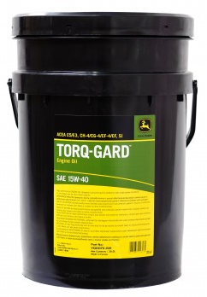 | Engine Oil 15W-40 20L Container | VC83070-020 |  | All
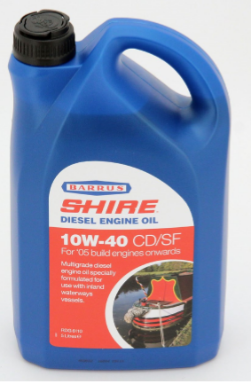 | Gearbox Oil 10W40 5L Container | RDG6110 | 1 | All
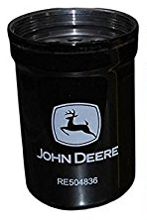 | Oil Filter | RE504836 | 1 | All
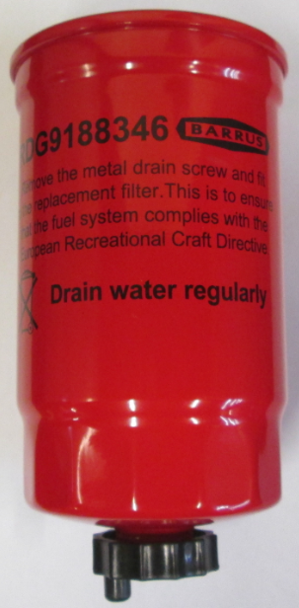 | Primary Fuel Filter* | RDG9188346 | 1 | All
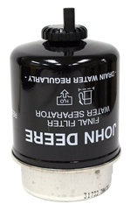 | Secondary Fuel Filter* | RE62418 | 1 | All
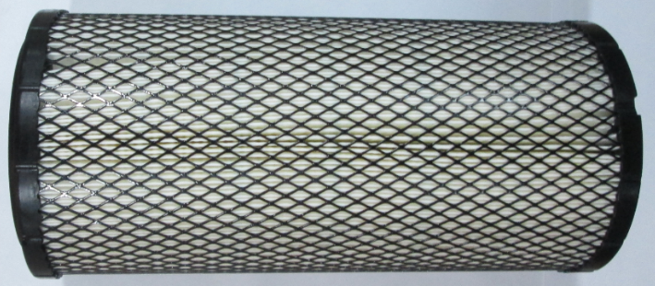 | Air Filter Element | RDG6650 | 1 | All

* Only filters which meet the Recreational Craft Directive should be fitted to your engine

