250 Hour Service
Shire 38/40/45/50
Boat Name: |  | Owner:
Location:
Engine Hours: |  | Date:

Description | Done | Comment
Check operation of all controls |  | Lubricate key switch
Check and adjust all alternator belts
Change engine oil filter (See Materials Used)
Change engine oil (See Materials Used)
Change gearbox oil (See Materials Used) |  | Oil required dependant on gearbox fitted
Change primary fuel filter (See Materials Used) |  | N/A for Shire 38
Change primary fuel filter (See Materials Used) |  | Fit the fuel filter drain screw and seal from the old filter to the new filter
Change secondary fuel filter (See Materials Used) |  | Change annually
Check all fuel pipes are secure/no chaffing
Check security of all electrical connections |  | Check behind the panel
Visual inspection of all wiring
Check coolant levels
Check all hose clips for security
Check all cooling water pipes are secure/no chaffing
Check alignment of engine/shaft
Check propeller is secure
Check tightness of engine mounting bolts
Check tightness of drive coupling bolts
Visual check of stern gland
Check operation of bilge pump

Materials Used
 | Description | Part No. | Qty | Model
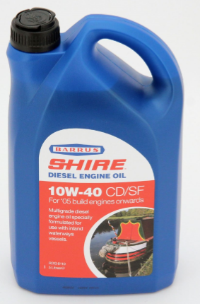 | Engine Oil 10W40 5L Container (This oil is also used for PRM 150 & 280 Gearboxes) | RDG6110 | 2* | All
No Image | ATF Oil for PRM 90 Gearbox (If fitted) | ATF-1L | 1 | All
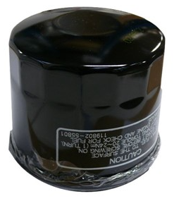 | Oil Filter | 129150-35170 | 1 | All
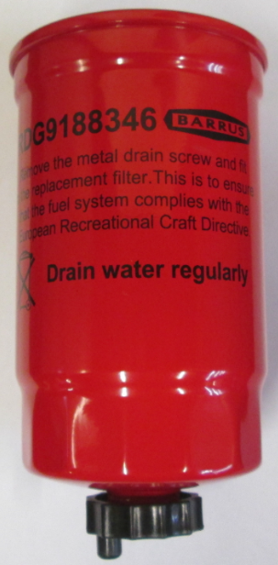 | Primary Fuel Filter** | RDG9188346 | 1 | Shire 40  Shire 45  Shire 50
 | Secondary Fuel Filter** | 119802-55810 | 1 | All

* A quantity of 2 is required even if a PRM 150 Gearbox isn’t fitted
** Only filters which meet the Recreational Craft Directive should be fitted to your engine

